Alderspring Ranch 2020 Internship Application
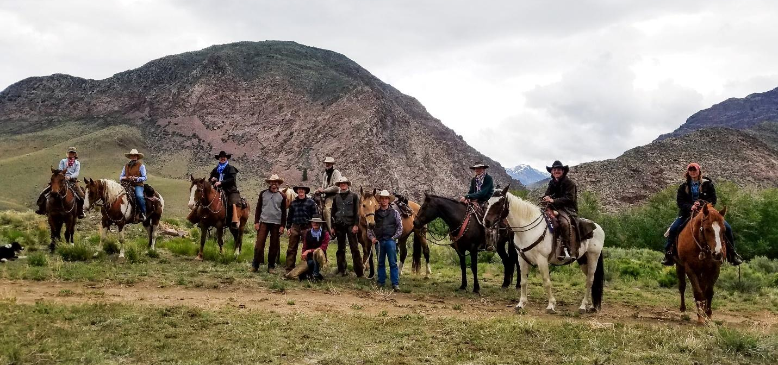
Please answer the questions below as completely as you can! And note that there are no right or wrong answers, we just want to get to know you and how you might fit on our crew!
When you are done filling out the document, just attach it to an email and mail to linnaea@alderspring.com.
Deadline: Please have your application sent to the above address by February 20, 2020! You should hear back from us within 1-2 weeks after the deadline on whether or not you’ve been selected for an interview.

The following are 4 requirements for this internship. Please check each box below to verify that you meet these requirements and understand what they mean. If the checkbox isn’t working, just put your initials there. Note that if you must meet ALL of the requirements below and check each box or we cannot accept your application.
☐ | You are a highschool graduate above 18 years of age
☐ | You are physically fit and can lift at least 65 lbs and can cover 5 miles in under 50 minutes
☐ | You are aware and accept that this is an unpaid internship, though you will be compensated with a $350 monthly stipend, beef at $2.50/lb, and housing
☐ | You are okay with appearing in videos, photos, and video interviews that may be widely shared on social media and in other forms of media

Contact Info
Your Preferred Email Address:
Your Preferred Phone Number:
Your Mailing Address:

Level of Education:
High School Grad | Some College | Bachelor’s Degree | Master’s Degree
☐ | ☐ | ☐ | ☐

Highschool Name, Graduation Date:
Most Recent Cumulative GPA (High School or College):
Name of College or University, if applicable:
Area of Study in College, if applicable:

Start and Ending Dates
Due to some time constraints on our end, the required arrival date for all crew members is May 18th. However, the ideal starting date is May 11th, and preference will be given to applicants who can come then. The ideal ending date is September 15, but if you have school commitments or something else, we can work with you for an end date of August 15 at the earliest.
Please enter here your earliest possible start date and latest possible end date:
Your earliest possible start date:
Your latest possible end date:

Previous Work Experience
Please describe the last three jobs you’ve held, your position, the business name and location, and the name of your employer/supervisor
Position 1:

Position 2:

Position 3:

References: Please list 4 references, preferably 2 work references, 1 personal, and 1 academic. For each reference, provide a name, email address, phone number, and how they know you.

Reference 1:

Reference 2:

Reference 3:

Reference 4:

Getting to Know You

The following questions will help us determine whether you will be a fit for our summer crew and for the nature of the work we do during the summer in the high country. Please answer these questions honestly; there really are no wrong answers. We're looking for a mix of personalities and skills in our crews, and honest responses will help us envision where you might fit.
We are aware that some people prefer to speak rather than write their answers, which we've given you the option to do. For all of the questions listed below in the “Video/Written Section,” you can record a video answer on your phone or write your response as you prefer.
We do have one question for which a 1-minute video response is required.
If you opt for all video, try to keep the total length at no more than 5 minutes, written responses at no more than 200 words each.
Upload your video to Google Drive, Dropbox, or Youtube and paste the link in the space below.

Video/Written Section (Write or Video Your Response)

Please provide a link to your video here:

Video Response Required:

Tell us a little bit about yourself, why you're applying for this job, and why you think you'd be a good fit on our crew.

Video or Written Response (Your Choice):

Please describe how you see this internship fitting into your future goals.

Based on what you know about Alderspring and regenerative agriculture, how do you think that the work we do at Alderspring matters?

Please briefly describe your prior horse experience in your own words. Do you have any interest in advancing your horsemanship and riding abilities?

Please describe any experience in the outdoors that you have had (eg., camping, hiking, skiing, hunting):

Would you describe yourself as mentally stable under stress (keeping in mind that many days on the range can be long and physically exhausting, mixed with periods of silence with a lot of time to think)? Please describe a previous scenario where you had to persist under stress.

Based on what you know about Alderspring and the job description, are there any particular areas of knowledge and skills that you hope to refine or expand during your time with us (like horsemanship, backcountry camping skills, etc.)?

Multiple Choice Selection
Please select the option you feel represents your experience herding and handling cattle:
☐ | What’s a cow?
☐ | No Experience. I literally have only seen cows in pictures.
☐ | Limited experience. I’ve observed or handled cattle only a few times.
☐ | Some experience. I’ve handled cattle multiple times, either on foot or horseback.
☐ | Experienced. I’ve spent hours herding and handling cattle.

Please select the option you feel represents your riding and horse handling experience:
☐ | No experience. I’ve never ridden or handled horses.
☐ | Very limited experience. I've been on a horse once or twice, but I'm not very comfortable around them.
☐ | Some experience. I've ridden multiple times and I think I could catch, lead, saddle, and bridle a horse unassisted.
☐ | Experienced. I've ridden many times and I am comfortable in all aspects of handling a broke horse.
☐ | Very experienced. I've ridden much of my life and I'm comfortable riding and training young or unpredictable horses.
☐ | I’m a world famous horse trainer, how have you never heard of me?

On a scale of 1-5, how comfortable are you with staying at a remote backcountry cow camp 3-7 days at a time with no amenities and the potential for inclement weather or run-ins with wild animals? (1 is “extremely uncomfortable, I would prefer to remain where there is running water, showers, cell phone service, and a roof over my head,” and 5 is “very comfortable, bring on the possible wildlife encounters, hard ground, snow and rain, and limited contact with the outside world!”)
Your rating:

Are you comfortable with firearms? Please note that we carry firearms while riding on the range in case we need to humanely terminate an injured animal, or in case of predator danger to crew members from wolves, bears, snakes, and mountain lions. We have NEVER had a situation in which firearm use was required for either injured animal termination or self defense, but for safety reasons each of our crew bosses will always be carrying a firearm. If you work with us this summer, you are not required to carry a firearm.
☐ | I don't know how to use a firearm and am uncomfortable with people around me using them.
☐ | I don't know how to use a firearm but I fine with others using them and/or am willing to learn to use one myself.
☐ | I know a little bit about handling firearms but do not own one.
☐ | I am familiar with handling firearms and own one/a couple
☐ | I am that person in the movies who is somehow always carrying like 30 weapons

Select how you would respond to the following scenario (there is no “right” answer. We want a diversity of personalities on our crew, and this question is really about gauging how you, personally, might react to things): Your crew is saddled up for the day and herding the cattle out of the night pen. You’re about two hills from camp (15 minutes’ ride) when you suddenly wonder if you’ve forgotten to turn off the camp stove this morning. If you forgot, all the propane will run out of the tank and your crew members will not be happy with you in camp tonight as they eat their cold dinners. However, if you return to camp to check, the rest of the crew will have to work extra hard to manage the herd without you for half an hour, and they’ll no doubt be frustrated about that. You’ve already asked all your crew members if they remember turning off the gas or not, but they are too sleep-deprived right now to remember anything (you ran out of coffee and it’s impacting everyone except that one annoying morning person, who is too busy singing the same cowboy song over and over again to be of any help to you). You’re pretty sure it is off, but not 100%. What do you do?
☐ | Go tell your crew boss you have to ride back to camp to check the gas and do the ride of shame, knowing the rest of the crew isn’t impressed. But it’s worth it for peace of mind.
☐ | Hope that you did indeed turn it off, don’t go back to camp, but be kind of worried about it for the rest of the day. It’ll be the first thing you check when you get back.
☐ | Figure you did turn it off (you’ve never forgotten something like that before), forget all about it, and join in with your fellow crew member, serenading the cattle with that stupid cowboy song.

Are there any other skills you have that weren’t covered above that you could see yourself bringing to the table this summer (feel free to think outside the box here a little)?

Is there anything else you'd like us to know about you or how you might fit on our crew?

Thanks for your time filling out this application!

